Main Agenda- To delete an attachment on click of a button manually

For this we need to use the class Link-Attachment and OOTB rule pyCaseRelatedAttachmentItem

Where in we can replace the dynamic layout with the delete button.

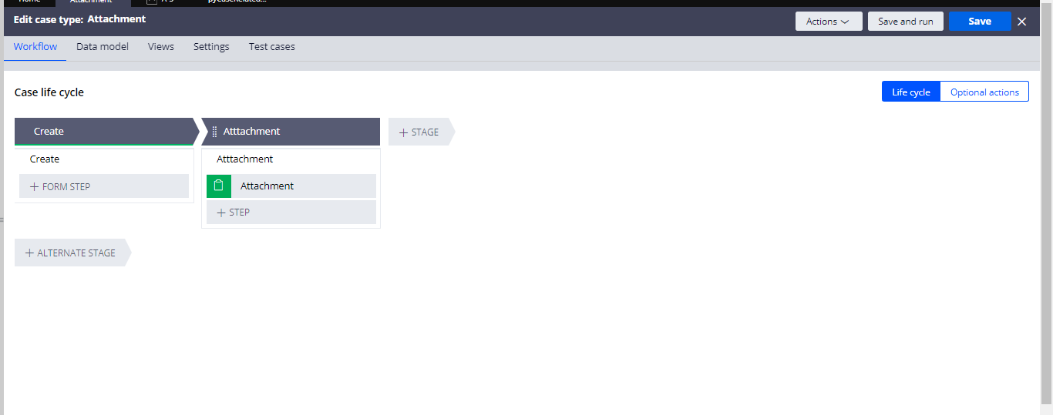

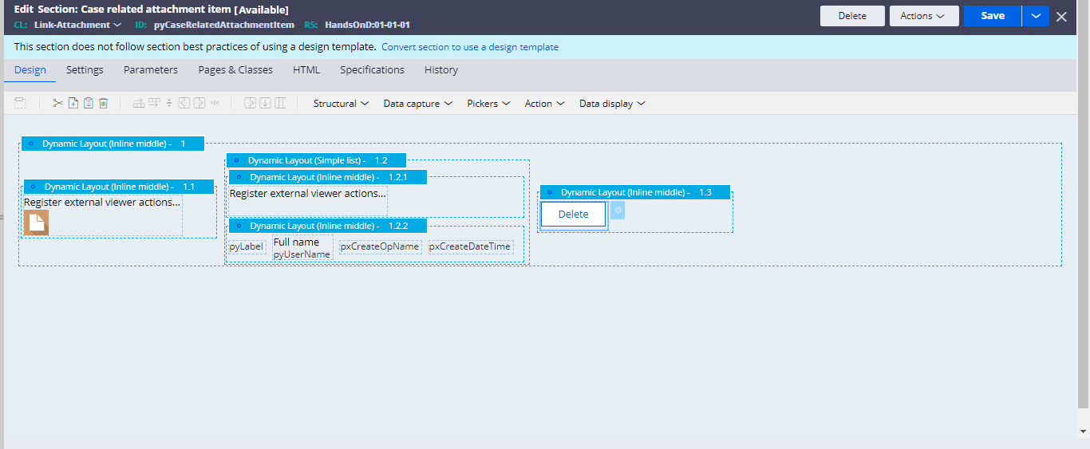

And after that can customize the delete buttons

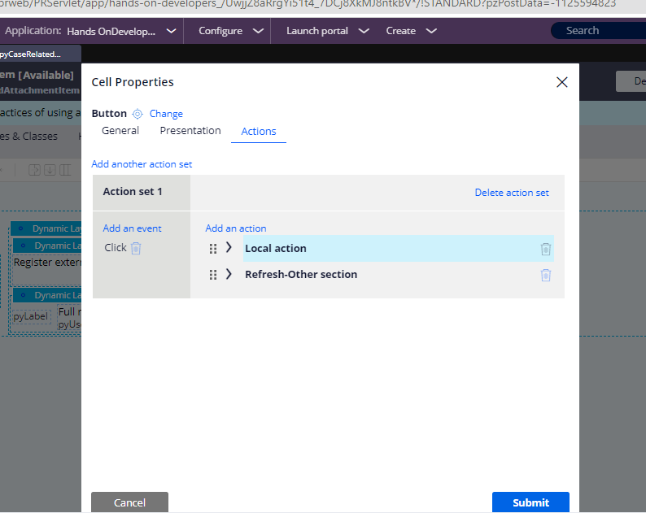

And in the Local Action and inside it give as Local Action as the pyDeleteAttachmentModal

And target as modal dialog so that it should reflect on the target and in the desktop reveal give None effects

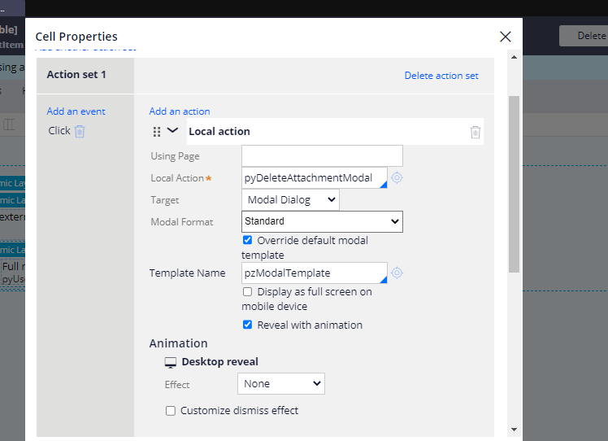

And in the refresh other section having class and give or section of the flow action and give the Activity as the pzRemoveAttachments

What this activity does it removes the datapage and the attachment that was attached to the Work Item those things are removed and also scans for any other attachment fields and removes the corresponding sync issues.

So after all these configurations can run a case and do and attach a file and go for attaching a content

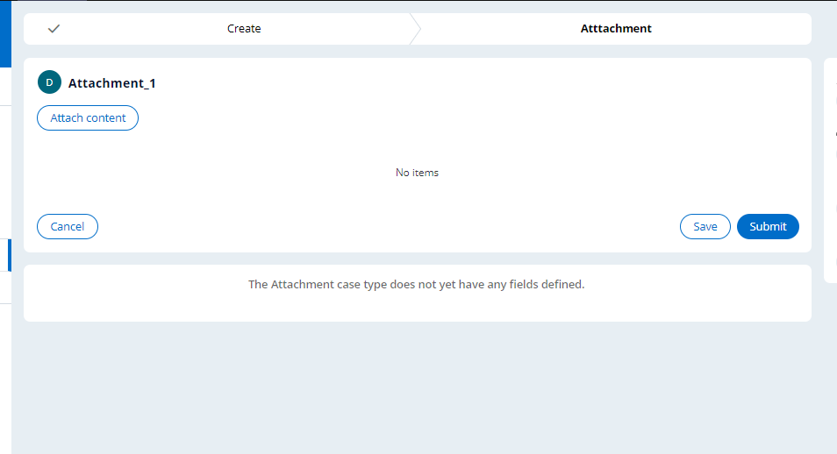

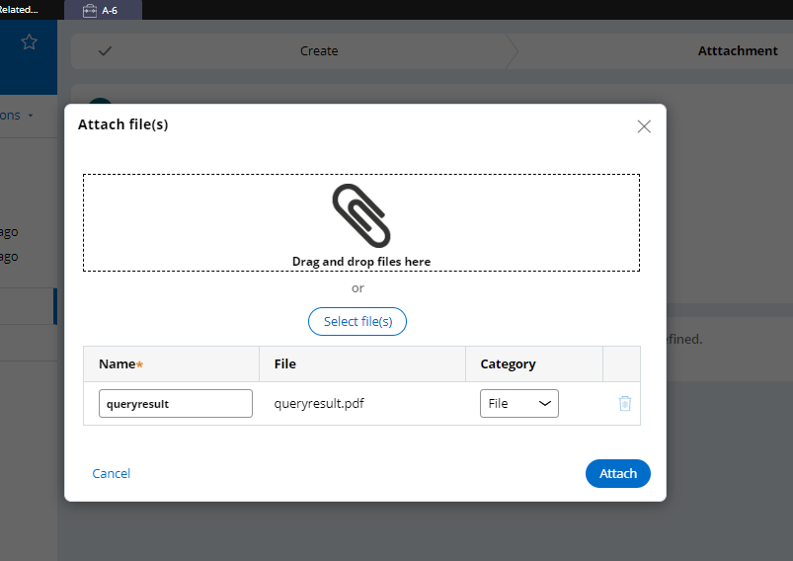

And attach an attachment file

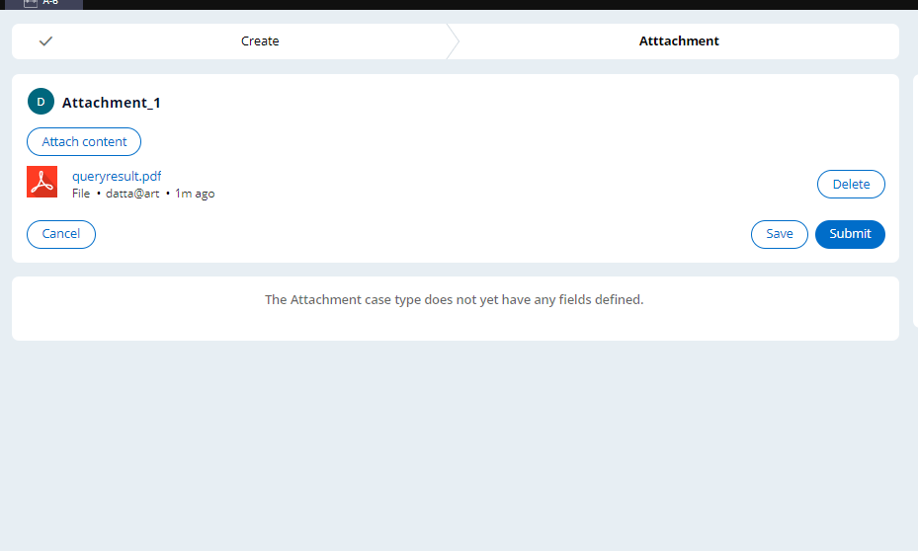

And in the clipboard under the pyAttachment Categories and can find the attached 1 file.

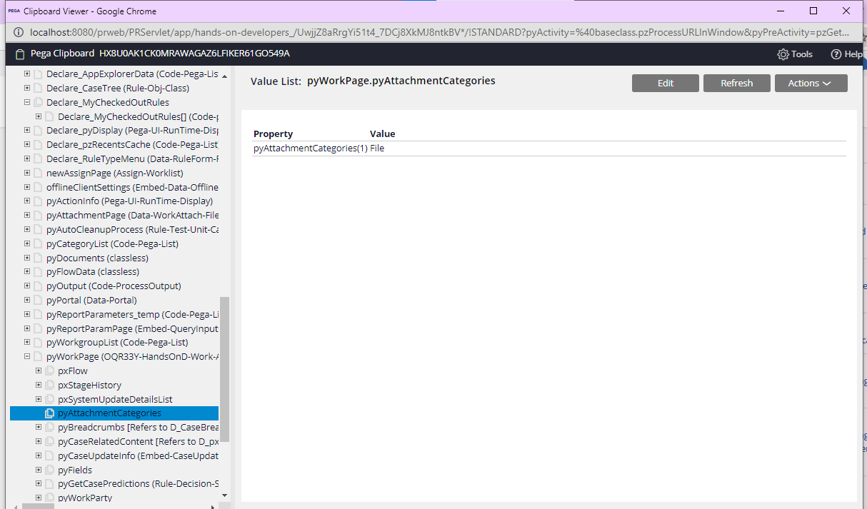

And under the pyAtachmentPage we can find our attachment name

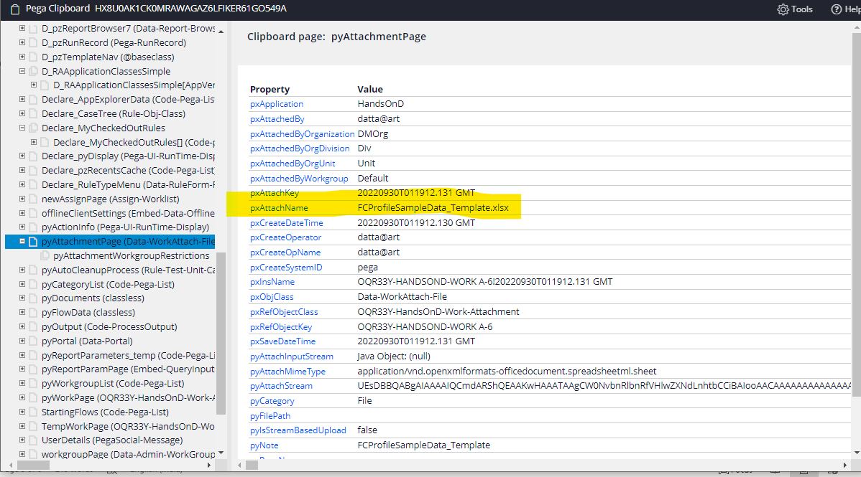

And now can delete and check in clipboard

And on the top right we can get the delete button which we customized and go for delete then a popup comes

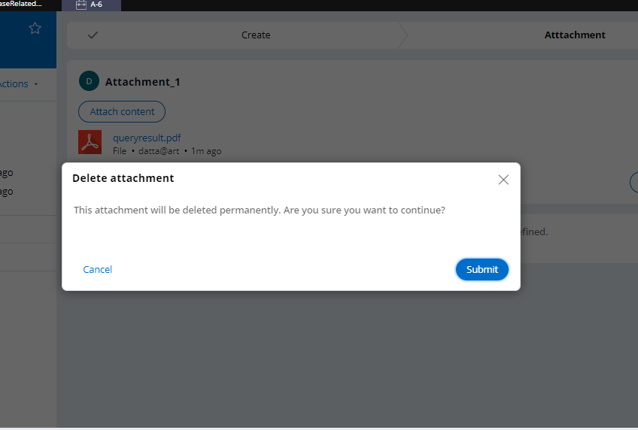

And then the attachment gets deleted

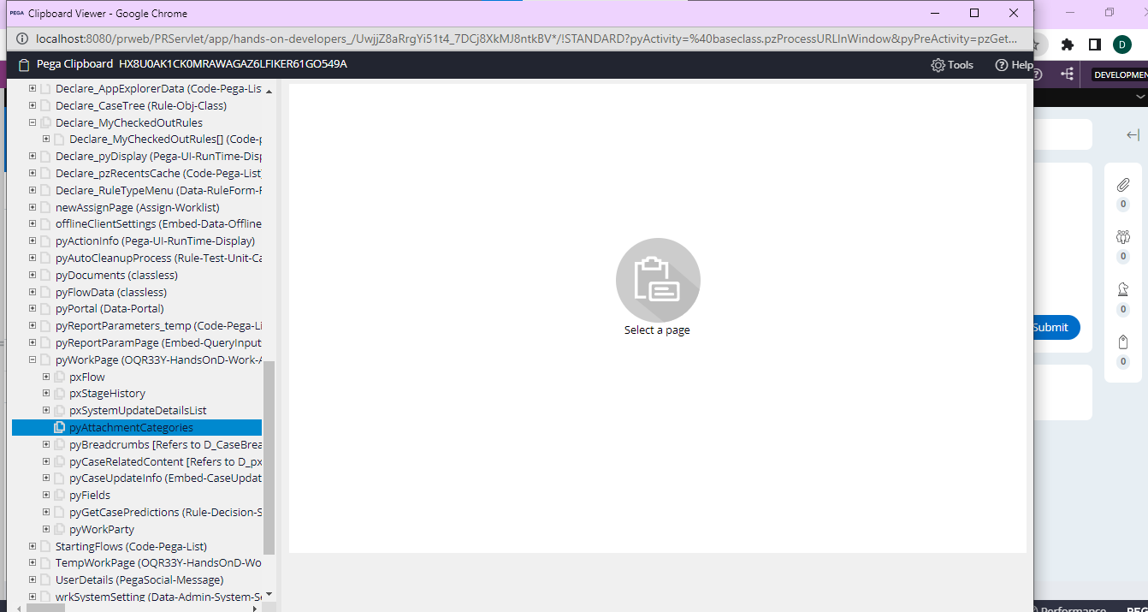

Under attachment categories can find no attachments now.